The connections Between Health and economic growth

Scientific methods (l1) – spring 2022

FARYAL KHAN

HAMNA JAMIL

Introduction

Motivation:

Health worldwide is accepted as a basic human right and indeed, for a country to prosper it is vital for its citizens to be healthy. The correlation between the two is well accepted; as in long run improvement in a country’s economy eventually results in improved health of its citizens. What is not very evident is that the improvement in health of a country’s people has the same effect on the economy as that of an improved economy of a country has on its citizens. The report of WHO’s Commission on Macroeconomics and Health [2001]1 states how improving health for the poor is a fundamental goal of economic development in a country. For lower income areas like the sub-Saharan Africa itself the burden of disease hinders the economic growth 2. Thus, it is to no surprise that health improvement has become a priority for countries worldwide. According to the World Bank Atlas Method about 10 million children are said to die in low-income countries, defined as gross national income (GNI) less than USD $1,005 every year3 .What startles us is how these global deaths from preventable causes could be alleviated if only enough amount from the government was spent on public health sectors as a consequence of increase in GDP per capita (current US$). It is therefore about time that we realize what huge impact GDP per capita could have on a country’s population health and analyze whether there exist other factor affecting it.

Research Questions:

The questions that we will be focusing on are as follows:

* Understanding the impact of economic conditions of a country on life expectancy at birth?

For this question we will be looking at the life expectancy for all the major countries at birth and then compare it with GDP per capita (US$) as a measure for economic growth for those countries for the year 2014. We expect a positive correlation between the two variables. A country with higher GDP per capita will definitely have a better life expectancy at birth as compared to those with lower GDP per capita.

* Does having a higher GDP per capita mean allocating higher budget for health and well being for population of a country?

In this question we will analyze whether there exists any prominent correlation between the two variables by comparing percentage of GDP spent on the health expenditure for countries India, Pakistan, China, and Sri Lanka with China and Sri Lanka being the developed countries and India and Pakistan developing countries. Our initial hypothesis is that countries with higher GDP per capita will spend more on the health sector for their population.

* How do financial conditions of a country affect the stunting rate of a country?

Economic conditions of a country are often also considered as a cause of poor nutritional outcomes; the stunting growth of children of that country. For countries with higher GDP per capita i.e., the developed countries we expect lower stunting rates as compared to the developing and under developed countries. To test the hypothesis, we will analyze data through graphs for 243 countries and draw conclusions whether there exists a correlation between the two variables.

* What effect does having financial stability have on the standard living of a country’s population?

With an increase in GDP per capita, standard of living generally rises and people have more resources to tackle communicable and/or non-communicable diseases and therefore we expect that as GDP per capita increases the mortality rate of a country decreases. Thus, proving that better economic conditions lead to better living standards improving the population health.

* Do countries with better economic conditions have lower infant mortality?

Infant mortality rate indicates how many babies die in the first year of their lives out of 1000 live births. We expect that increasing GDP per capita will decrease infant mortality rate. We test our hypothesis on countries India, Pakistan, Sri Lanka, and China with data from world bank over the span of 60 years.

Literature Review

## Healthcare Expenditure and Economic Performance:

This detailed article provides an analysis on the relationship between Healthcare and Economy. Over the years, education and other factors were thought to be directly linked to economic growth but in recent years, researchers have found fair amount of data on the relationship between health and economic growth. Both are crucial indicators for overall growth of the country. “According to Fogel (1994), approximately one third of GDP of Britain between 1790 and 1890 outcome of improvements in health especially improvement in nutrition, public and medical care facilities and these improved health facilities should be considered labour enhancing technical change”4. Hence there is a bi-directional link between health and economic growth because a healthier population leads to people being actively engaged in economic activities. On the other hand, better GDP will lead to more budget being allocated on the improvement of healthcare facilities.

Data analysis portrays that Healthcare expenditure is directly linked to increasing labour productivity. It also suggests that developed countries spend on healthcare as an investment in human capital (since labour can give better productivity in industries and hence increase GDP) as compared to low-GDP countries where preventive measures are not taken to control the prevalence of disease. As a result, when cases increase, Government organizations don't have enough resources to tackle these issues.

## The Long-Term Impact of Health on Economic Growth in Pakistan:

This paper by Akram et al4, discusses the above relationship in context to Pakistan’s data. Pakistan’s human capital shows a pattern of increase over the years. But according to UNDP, Pakistan’s Human Development Index as of 2020 is below average which indicates very slow growth 5. There were multiple reasons identified to explain this situation in the country. A big chunk of the population in Pakistan lives in villages but healthcare facilities are mostly not available or are not sufficient in those areas. Moreover, priority is given to development of healthcare facilities in urban areas which results in smaller villages being completely ignored. After rigorous analysis using cointegration and error-correction models, it was found that health indicators only impact GDP per capita in the long term.

## Health Policy and Economic Growth in India:

This paper discusses irregular distribution of resources in the health sector. “There is evidence of substantial resource waste in both urban settings where there is an over-prescription of medicines that are not needed and in rural settings where subsidies to public health facilities do not translate into better care” 6 It is also noticeable that in both of these countries, medical expenses usually turn out to be a major burden for low-income families and lead to poverty. According to the UN, in 2020, 86% of new TB cases occurred in the 30 high TB burden countries. Eight countries accounted for two thirds of the new TB cases: India, China, Indonesia, the Philippines, Pakistan, Nigeria, Bangladesh and South Africa7. This can be associated with the slow progress of the economy in these countries since diseases such as TB increases mortality rate which in turn negatively affect economic growth. Moreover, prevalence of disease also leads to reduced productivity in rising industrial countries like Pakistan and India.

## Economic Growth, Health and Poverty:

This paper discusses economic growth and health and their implications on poverty. It establishes that the results of good health on the economy would be prevalent only in the longer-run. “These effects would take place over a few generations, and would have to be sustained over a longer term for the effect to be felt on growth rates”8 This is because first governments need to establish a strong-enough foundation of health infrastructure and once that is done, the economy is not as such disturbed. In the analysis, a strong connection between poverty and infant mortality was found. Meanwhile a mild association between other health and economic growth variables was found.

# Methodology

For our analysis, we will mainly be focusing on four countries; Pakistan, India, China, and Sri Lanka but we will also include a general analysis for possibly all of the countries the data is available.

The methods and tools used to analyse our data are regression and median.

Regression is a useful method for our context because it gives us a measure of how much a variable depends on other variables. Since, in our case, we are finding a relationship between different health variables and economy; regression helps to determine the rigidity of this relationship. The other tool we use is median. Median gives us a benchmark value so we can compare statistical data for our chosen countries with this median value. Furthermore, to visualize patterns in the data, we use bar, line and scatter plots.

Analysis and Result

Using the tools mentioned above, we will now present our analysis of health variables with GDP per capita.

## General Domestic Health Expenditure per capita:

To determine the effect of GDP on Health expenditure, we plotted percentage of GDP spent on

health expenditure and GDP along with median (of all countries) on a bar chart to visualize the pattern.

We expected that these two variables would be directly proportional to each other but instead we found that countries with lower GDP per capita spend more on healthcare expenditure as shown in Fig-1. Our result is backed up by this paper which states “governments’ domestic health expenditure has increased over time in developing regions, growing at a rate of 5% between 2000 and 2003 and 9% from 2003 to 2006” 9. The reason as stated by WHO’s report is that in countries with low GDP per capita, government healthcare saves people from falling into poverty while seeking healthcare10.

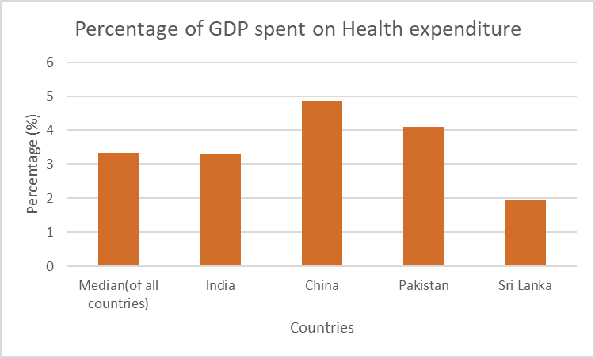

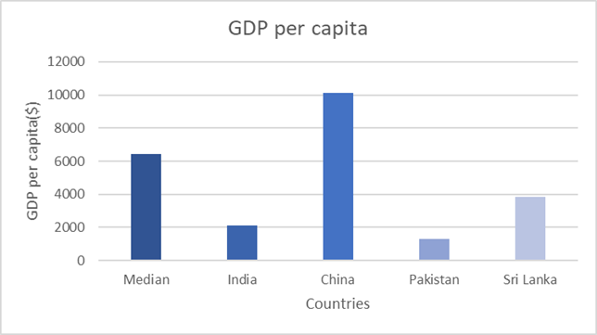

Fig-1 (A comparison between Health Expenditure % and GDP per capita)

Life Expectancy:

We are using life expectancy at birth to represent population health here. Our reason to employ this variable as an indicator of population health is the fact that it shows a strong correlation with other indicators of population health (like infant mortality, mortality rate etc). This part of the research is centred around finding a correlation between a country’s GDP per capita (current US$) and its life expectancy in years. The hypothesis is that both these variables have a positive correlation, that is, when the GDP per capita for a country increases, a rise in life expectancy for that country is observed. Hence via cause-and-effect relationship we choose GDP per capita as our independent variable since it speaks about other population health related indicators such as health expenditure which directly affects life expectancy. In order to analyse the data at a comparable level we make use of a regression model in our research. All of the data for GDP per capita and Life Expectancy at birth that we have collected comes from the World Bank and is based on 2014 for regression purposes.

Through a simple regression performed on our two variables we obtained the following equation in the form y = mx + c:

Life expectancy at birth = 2.06E-04 (GDP per capita) + 68.18

From the above equation ‘m’ is found to be 0.000206 which means that as GDP per capita (current US$) increases by 1, the life expectancy increases by 0.000206 years. Our hypothesis for a positive correlation is also supported by the graph shown in Figure 4 which shows a positive slope for the two variables. The graph depicts that wealthier countries have higher life expectancy at birth.

Fig (2) Life expectancy at birth, total (years) versus GDP per capita (current US$) for 243 countries for the year 2014.

To further explore the relationship between life expectancy as a representation of population health and GDP per capita (US$) along with other indicators that may affect the population health we conducted a multiple variable regression:

Y= -0.08 x1+7.89E-05 x2+2.49E-05 x3-1.90E-04 x4 + 73.5

where;

y = life expectancy at birth (total years)

x1 = infant mortality rate

x2 = GDP per capita (current US$)

x3 = prevalence of stunting

x4 = Health expenditure

Our regression analysis confirms a positive impact of GDP per capita (current US$) on Life expectancy at birth and a negative impact of infant mortality rate on life expectancy. However, Health expenditure and prevalence of stunting do not seem to have an effect on the life expectancy for the predicted value for both health expenditure and prevalence of stunting both was greater than 0.05.

Stunting Rate:

Economic conditions of a country are often also considered as a cause of poor nutritional outcomes often resulting into stunting growth of children of that country. To find whether a correlation between the two exists we use World Bank datasets for 198 countries for the year 2019. We hypothesize that countries with GDP per capita (current US$) will have lower stunting rates. To analyze our data, we plot a scatter plot graph of prevalence of stunting, height for age (modeled estimate, % of children under 5) against GDP per capita (current US$). Fig (3) shows the result of the data that we collected:

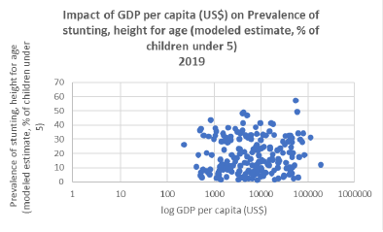

Fig (3) Impact of GDP per capita (US$) on Prevalence of stunting, height for age (modeled estimate, % of children under 5) for year 2019

Fig (3) however depicts that there is no such evident correlation between the two which to our surprise falsified our initial hypothesis. This could also be seen through the correlation value that we obtained for GDP per capita and prevalence of stunting which was 0.08 which goes on to explain economic conditions of a country do not have any significant effect on stunting rate.

## Mortality rate in adults:

## We performed regression with GDP per capita as independent variable ‘x’ and mortality rate as dependent variable ‘y’. We get the equation: y = -0.005x+384.057. Negative slope value here represents that with increase in x, y decreases which is in-line with our initial hypothesis.

## Infant Mortality:

Infant mortality is another important variable to determine our connection between health and economy. Infant mortality rate indicates how many infants die in the first year of their lives out of 1000 live births. This part of the research is again, centered around the country’s GDP per capita (current US$) to figure out the extent by which economic development as measured by the GDP leads to a reduction in infant mortality. The hypothesis is both the variables are inversely proportional i.e., higher GDP means a lower infant mortality as shown in Fig-4.

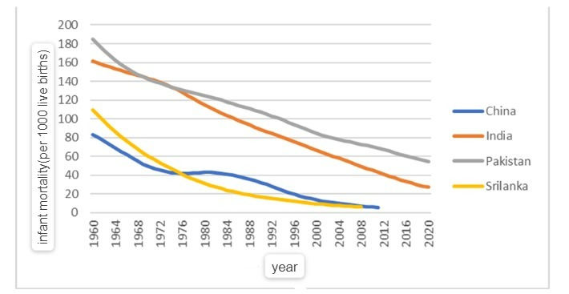

Fig-4(Trend in infant mortality over the years)

The result not only indicates a strong connection between economic growth and Infant mortality, but “All countries with a GDP below 1000$ have got an IMR above 40‰. All the countries below 3000$ have got an IMR* above 30‰. Conversely, all the countries above a GDP of 30,000$ have got an IMR below 6‰.”11 This clearly indicates that in the long run, the development of the economy will lead to fewer babies dying in the first year of their life.

# Conclusion:

To summarize our findings on the relationship between Health and Economic growth, we found that life expectancy, mortality (adults and infants), and stunting rate affect GDP per capita. While in the case of Healthcare expenditure, since the analysis did not coincide with the initial hypothesis, it was falsified. Since the relationship is evident, countries should work on improving healthcare conditions like better facilities and better sanitation and better nutrition could help prevent communicable and non-communicable diseases. This would in turn improve the economy and alleviate poverty.

There are a lot of other Health variables that affect the economy of a country. One such variable could be fertility rate which would verify the relationship between population growth and economy. To further improve this study, availability of data on common diseases like TB, malaria would help justify the reason some countries spend more on healthcare. For a more constructive study on the topic, availability of accurate data is crucial.

References:

1. World Health Organization. (1970, January 1). *Macroeconomics and health : Investing in health for Economic Development : Executive summary / report of the commission on macroeconomics and health*. World Health Organization. Retrieved May 11, 2022, from https://apps.who.int/iris/handle/10665/42463
2. Weil, David. (2005). ACCOUNTING FOR THE EFFECT OF HEALTH ON ECONOMIC GROWTH. https://academic.oup.com/qje/article-abstract/122/3/1265/1879531?redirectedFrom=fulltext /

# Martin, G. and Grant, A. and D’Agostino, M. (2012). Global health funding and economic development. <https://globalizationandhealth.biomedcentral.com/articles/10.1186/1744-8603-8-8>

1. Akram, N., Padda, I. and Khan, M., 2008. The Long Term Impact of Health on Economic Growth in Pakistan. *The Pakistan Development Review*, 47(4II), pp.487-500.
2. IGC. 2022. *Menon synthesis paper 2017 update - IGC*. [online] Available at: <https://www.theigc.org/publication/health-policy-economic-growth-india-lessons-international-growth-centre-projects/menon-synthesis-paper-2017-update/> [Accessed 8 March 2022].
3. Library.fes.de. 2022. [online] Available at: <https://library.fes.de/libalt/journals/swetsfulltext/19142301.pdf> [Accessed 8 March 2022].
4. Who.int. 2022. *Tuberculosis (TB)*. [online] Available at: <https://www.who.int/news-room/fact-sheets/detail/tuberculosis> [Accessed 8 March 2022].
5. Sharma, R., 2022. *Health and economic growth: Evidence from dynamic panel data of 143 years*.
6. Raghupathi, V. and Raghupathi, W., 2022. *Healthcare Expenditure and Economic Performance: Insights From the United States Data*.
7. World Health Organization. (n.d.). *Countries are spending more on health, but people are still paying too much out of their own pockets*. World Health Organization. Retrieved May 11, 2022, from https://www.who.int/news/item/20-02-2019-countries-are-spending-more-on-health-but-people-are-still-paying-too-much-out-of-their-own-pockets
8. DaVanzo, Julie. “Infant Mortality and Economic Development” *RAND*, 1 Jan. 1986, www.rand.org/pubs/research_briefs/RB5002.html. Accessed 5 Apr. 2022.            [Infant Mortality and Economic Development | RAND](https://www.rand.org/pubs/research_briefs/RB5002.html)